**Experiment No. 2.3**

**Student Name: Lucky UID: 22MCA20083**

**Branch: MCA Section/Group: MCA 2 / A**

**Semester: I Date of Performance: 10th Dec 22**

**Subject Name: Front-End Web UI Subject Code: 22CAP-606**

1. **Task to be done:**

**Write** **a PHP Script to decode a JSON String.**

1. **Code for experiment/practical:**

<?php

$someJSON = '{"name" : "Lucky", "Rishav" : "Jesu"}';

$someArray = json_decode($someJSON, true);

foreach($someArray as $key => $value) {

echo "[" . $key . "][" . $value . "]"; }

?>

**3. Result/Output/Writing Summary:** 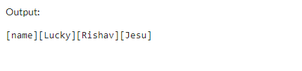

**Learning outcomes (What I have learned):**

**1. Learned a PHP Script to decode a JSON String.**

**Evaluation Grid:**

|  |  |  |  |
| --- | --- | --- | --- |
| Sr. No. | Parameters | Marks Obtained | Maximum Marks |
| 1. | Demonstration and Performance |  | 22 |